**Background**

At the September 2025 meeting, council was asked to consider whether to repair or replace the council’s broken printer. Council agreed it would most likely be cost-ineffective to attempt to repair the printer. Costs for various options to replace the printer were available, but the council would not authorise the clerk to purchase a replacement machine without the production of three written quotes. A request to include laser jet printer options was made. Accordingly, this background paper provides the written information as requested.

The current printer is an HP Deskjet 2710, which I cannot see is still in production.

**Option 1 - £54.99** *(This model seems to be the nearest like-for-like replacement of the Deskjet 2710)*

HP DeskJet 2810e All-in-One Wireless Printer | Scan & Copy | 3 Months Free Instant Ink with HP+

This is A4 only.

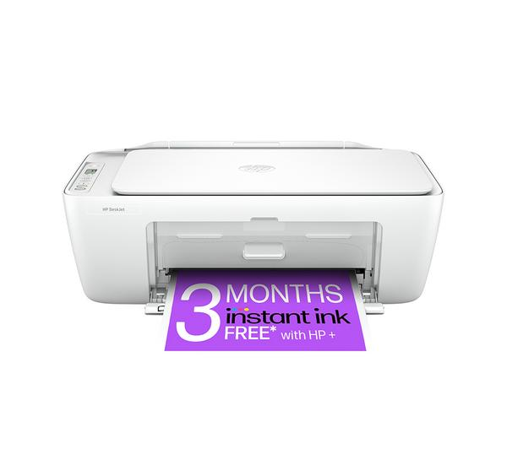

<https://www.currys.co.uk/products/hp-deskjet-2810e-allinone-wireless-inkjet-printer-and-instant-ink-with-hp-10255988.html?srcid=198&cmpid=ppc~gg~1012+(Shopping+Ads)+Printers+-+PMAX~~Exact~22660314867~&mctag=gg_goog_7904&kwid=MICROSOFT&device=c&ds_kids=&tgtid=1012+(Shopping+Ads)+Printers+-+PMAX&&msclkid=858c203a372219123d1a48db2e16f9a1&utm_source=bing&utm_medium=cpc&utm_campaign=1012%20(Shopping%20Ads)%20Printers%20-%20PMAX&utm_term=2323955266034871&utm_content=Asset%20Group%201&gclid=858c203a372219123d1a48db2e16f9a1&gclsrc=3p.ds&gad_source=7&gad_campaignid=22660314867>

**Option 2 - £149.00**

HP OfficeJet Pro 9720e A3 Colour Multifunction Inkjet Printer with HP+ and 3 months Instant Ink

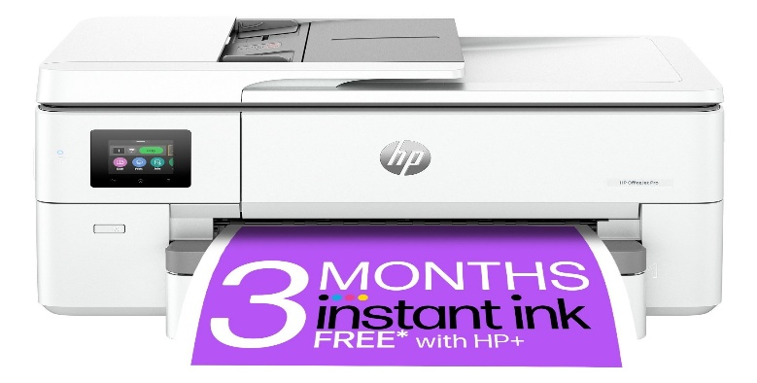

<https://www.hp.com/gb-en/shop/list.aspx?fc_msize_a3=1&fc_ptyp_printers=1&sel=PRN>

**Option 3 – Laser Jet Printers - Various @ £240 to £350 for A4 and £882 for A3**

<https://www.printerland.co.uk/product/brother-mfc-l3760cdw/152899?source=BingAdsMFCL3760CDWZU1&msclkid=750382744b8e13e6c6f3ea956f775975&utm_source=bing&utm_medium=cpc&utm_campaign=Shopping%20%7C%20Laser%20Printers&utm_term=4575411504595034&utm_content=Laser%20Printers>

**HP LaserJet Professional CP5225 A3 Colour Printer**

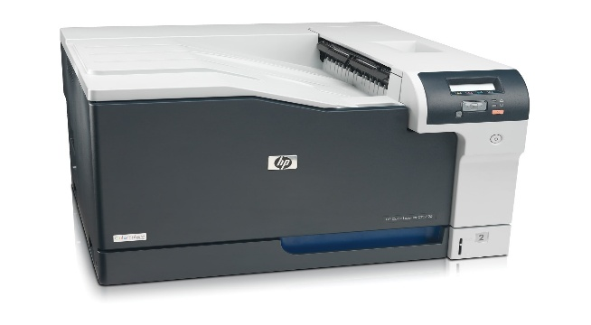

<https://www.hp.com/gb-en/shop/product.aspx?id=CE710A&opt=B19&sel=PRN&jumpid=cs_gb_bg_st_mc_cm018581_cv_px_concompr&utm_source=bing&utm_medium=cpc&utm_campaign=GB_PRN_SmartShop_NoA_Pri_ComCon_Bing_OPEX_ENG_CM018581_Low-Priority&addisttype=o&kw=&adid=&infinity=ict2~net~gaw~cmp~~ag~~ar~~kw~~mt~e&msclkid=0f178bd115641c6cb820e3303666940b&gclid=0f178bd115641c6cb820e3303666940b&gclsrc=3p.ds&gad_source=7&gad_campaignid=22169331771>

**Clerk’s Preference**

Colour printing is essential, and a machine with A3 capability would be useful, particularly when it comes to setting the budget/precept.